We prioritise transparency and integrity in our finances and that's why we have made our financial information available to the public. We value the trust of our donors greatly, which is why we remain dedicated to being accountable for every cent that comes in and goes out.

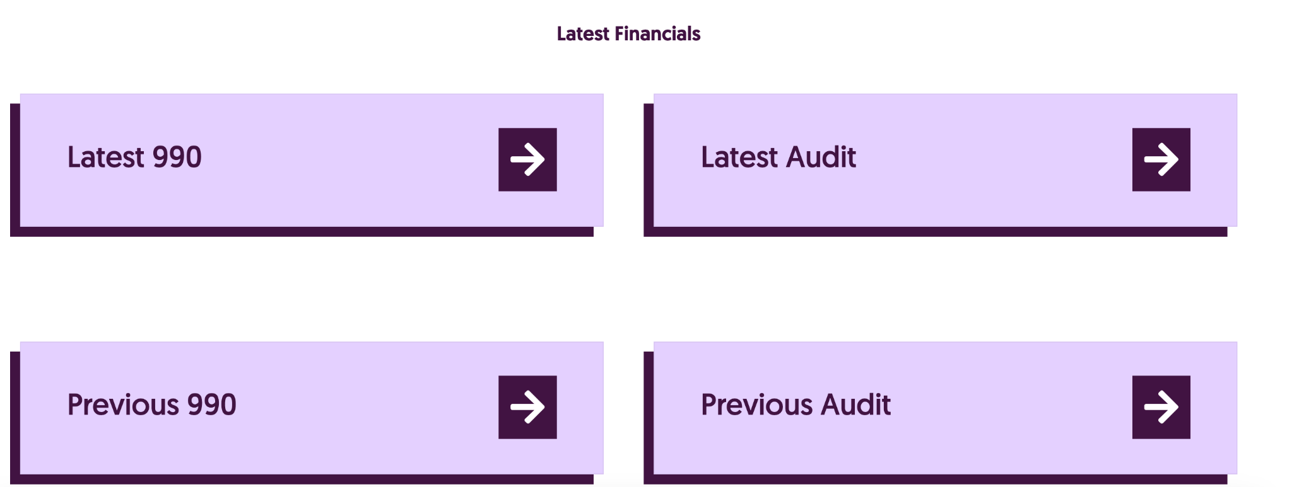

TRANSPARENCY REPORT

Our transparency report include monthly activity reports, monthly bank statements, financial breakdown and annual impact reports

**Monthly activity reports**

Our monthly activity report serves as our diary, providing you with an overview of our interactions with vendors, communities, women, employees, and more.

Subscribe to our newsletter to know more!

*subscribe icon

Monthly bank statements

This official monthly bank statements show our incoming and outgoing transactions.

**Financial breakdown**

This is a detailed spreadsheet that gives you a clear picture of our financial standing. You can find all our inflows and outflows of funds here.

Annual impact reports

Our annual impact reports will provide details of our Organisations’s achievements, challenges and future plans.

**Guidance:**

Please remember that they will be PDF documents.

Financial breakdown is an excel spreadsheet

Our annual impact reports will not be ready now as we haven't be active for us to a year. So if you can have something graphical to illustrate that please. Maybe something like come back later? Or anything